Pre Kindergarten - Supply List
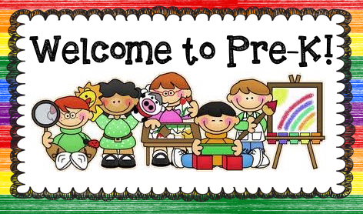
2022-2023

We welcome you and your child to Pre-K!

Clearly label ALL items with your child’s first and last name.

Thank you!
Please send in the following items:

- A shoe box
- Change of clothes – shirt, pants, underwear, sneakers, socks
- A towel or blanket for rest time
- A large full-size backpack
- 1 pictures of your child’s family
- 1 pictures of your child
- 1 folder (with pockets on the bottom)
- 1 black and white marble notebook
- 1 pair of childrens blunt edge scissors

The following is a suggested list of items for the classroom:
- Box of Puffs Plus tissues
- 1 gallon size box of Ziploc bags
- 1 2-gallon size box of Ziploc bags
- paper towels
- Clorox wipes
- hand sanitizer
- liquid soap
- 1 bottle of Elmers glue
- 3 glue sticks
- 1 package of dry erase markers

