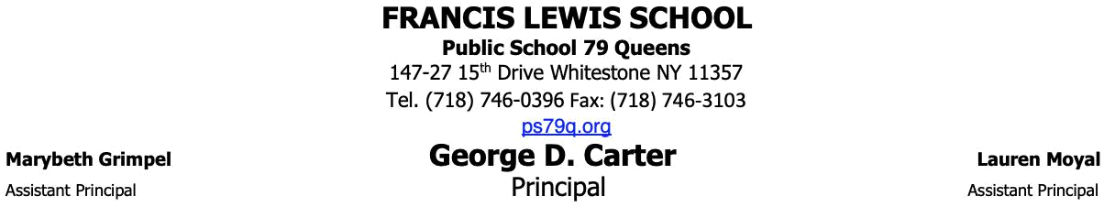

 | S | C |  |  | K.1.2 - S |  | L
 |  |  |  | 2023-2024
Bel |  | i a li | f i em |  | ha | child | ill need f | he | ch | l | ea While he e i | a
gge |  | ed | de | in | hich | end he i em in |  | ma |  | end | hem in in an | a
ha make i |  |  | m | e manageable f |  |  | and | child a |  | he e a e e e al i em
Plea e |  |  |  | ide a back |  | ack ha i | la ge en | gh | fi | a la ge f lde and l nch


- In addition, please make sure your child’s backpack and lunch box are clearly labeled with their name and class.


SEPTEMBER (Day |  | ):
P ea e | e d he e i e |  |  |  | he fi |  | da | f
ch | :
❏ 4 bottom |  | cke |  | la | ic f | lde | i h | cke
 | ❏ 1 bl | e, 1 |  | ed, 1 ell |  |  | , 1 g een
❏ 2 P ima J |  | nal n |  |  | eb | k | f g ade K-2
 | ❏ 1 WITH |  |  |  |  | ,
- 1 WITHOUT

❏ 2 b | e | f #2 Tic | nde | ga | encil
i h e a e
❏ 2 b | e | f C a | la c a | n (24) | ALL
❏ 1 | l | ca e ( |  |  | ALL
SUPPLIES - c a |  |  | n , | encil , ci | , gl e
ick).
❏ 1 | ackage f c l |  | ed | encil
❏ 1 | ack | f C a la Magic Ma ke
❏ 1 | ai | f child en | ci | (if | child i
lef -handed, lea e |  |  |  | cha e lef -handed
ci |  | )

- 1 la -d h

❏ 1 en f en bin in cla

(P -i , kine ic and, i h ball, e c).

Please also include an extra set of labeled

clothes (shirt, pants, underwear, socks) in a

labeled bag.

SEPTEMBER (Day ):
P ea e | e d he e i e |  | he ec d da f
ch | :
- 1 bf gall n Zi l c bag

❏ 1 b |  | f Zi l |  | c | a | i e bag
❏ 2 b | e | f | i | e
❏ 2 | ll | f | a | e | el
❏ 2 la ge gl |  |  | e | ick
❏ 1 | ackage |  |  | f bab | i | e
❏ 1 | ackage |  |  | f d | e a e ma ke (fine i )

and e a e

- 1 black ha ie

SEPTEMBER D |  |  |  | 3:
P ea e |  | e d | he e i e |  |  |  |  |  | he | hi d da |  |  | f
ch : |  |  |  |  |  |  |  |  | ea b d ). P
❏ 1 |  | e | f head h |  |  |  | ne | (n
 |  |  |  | !
❏ 1 |  | eam f c m |  |  |  |  | e | in ing a e (8 1/2
11)
❏ 1 |  | ackage |  | f clea |  |  |  | la | ic | hee / | age
 |  | ec
❏ 1 |  | ackage |  | f c l |  |  | ed ca d |  |  | ck | a e |  | (8 1/2
 |  | 11)

PS Instructional Focus

In order to strengthen our ELA and Math instruction, we will strive to embed protocols that promote academic discussions within our classrooms,
thus fostering critical thinking within our daily lessons

JANUAR SUPPLIES:

P ea e e d he e i e i Ja a :

- 1 bf and ich i e Zi l c bag

❏ 1 | ackage |  |  | f d | e a e ma ke |  | (fine i | )
❏ 1 | ackage |  |  | f clea la |  | ic hee | ec
❏ 2 b |  | e | f c a |  | n
❏ 2 b |  | e | f i |  | e
❏ 2 | ll | f | a | e | el
❏ 2 gl |  | e | ick
❏ 1 eam |  |  | f c | m | e / | in ing a | e (8 | 11)
❏ 1 | ack |  | f | -i
❏ 1 | la -d |  | h
- :


P ,

; , , , , .

.

Tha k ! I k f a d a de f ch ea .

