Kindergarten Supply List
2022-2023
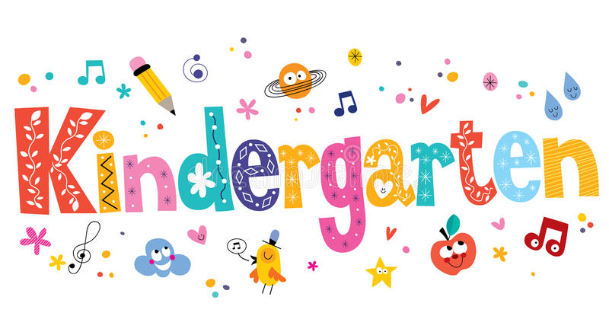
The Kindergarten teacher team can’t wait to begin the new school year and meet the children. To make it easier in September, we have prepared a list of supplies for the upcoming school year which is divided into two groups – supplies for September and supplies for January. Please try to label your child’s items (first & last name).

SEPTEMBER (First Day of School):  Please bring these items on the first day of school  - 1 box #2 Ticonderoga sharpened pencils with erasers  - 1 package of Papermate erasers  - 1 Fiskar metal scissors  - 2 large glue sticks  - 1 pack of Post-its  - 1 boxes of Crayola crayons (24 count)  - 1 box of magic markers  - 1 package of dry erase markers and eraser  - 1 Sharpie marker (Fine Point)  - 1 plastic pencil box  - 4 plastic folders with bottom pockets:  - red,  - blue,  - yellow,  - green  - 1 Mead Primary Journal notebook | - 1 box of tissues  - 1 roll of paper towels  - 1 pair of headphones (not earbuds) in a baggie labeled with your child's name.  - $10.00 – we will subscribe to Scholastic Magazine  - Change of clothes(socks, pants, shirt, underwear) labeled in a bag.  Girls Only:  - 1 package of Xerox paper -8 1/2 x 11 20  - 1 box of gallon Ziploc bags  Boys Only:  - 1 package of paper plates  - 1 box of colored xerox paper- 8 ½ x 11 20
JANUARY SUPPLIES:
Please send these items in January

- 1 box #2 Ticonderoga sharpened pencils with erasers
- 1 box of Crayola crayons (24 count)
- 1 box of tissues
- 2 large glue stick

Every day the children will have a healthy snack in the afternoon
Suggestions: fruit, yogurt, cheese, etc. and drink

Thank you!
The Kindergarten Teachers

