Second Grade Supply List
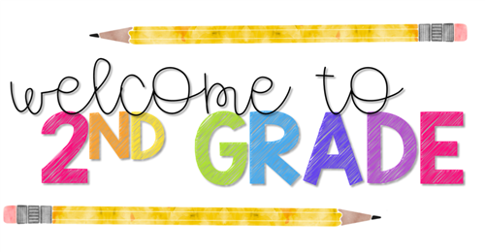
2022-2023

As this school year comes to a close, we would like to wish you a healthy, safe and happy summer vacation. Below is the list of supplies for the upcoming school year. Please label your child’s items (first & last name).

SEPTEMBER (Day 1):  Please send these items on the first day of school  - 6 Mead marble composition notebooks (no spiral notebooks)  - 1 block pencil eraser  - 8 plastic folders with pockets on the bottom  - 2 red  - 1 orange  - 2 yellow  - 1 green  - 2 blue  - 4 boxes of sharpened 20-pack pencils (Ticonderoga preferred)  - 1 box of 24 crayons (Crayola preferred)  - 1 8-pack broad line classic color markers (Crayola preferred)  - 1 large pencil case  - 1 blunt nose scissors  - 3 jumbo glue sticks (Elmers preferred) | SEPTEMBER (Day 2):  Please send these items on the second day of school  - 1 clipboard  - 4 packages of 3x3 post-it notes with lines  - 2 packages of 4x4 post-it notes with lines  - 1 package of black ultra fine point Sharpies  - 1 package of black fine point Sharpies  - 3 rolls of scotch tape in the dispenser  (Scotch brand preferred)  - 1 box of Ziploc gallon size bags  (press to close please, NO slider)  - (2 ) Click 4-color retractable pens  - 1 Pack of THICK Black dry erase markers (EXPO preferred, some other brands do not erase)  - 1 Pack of THIN Black dry erase markers (EXPO preferred, some other brands do not erase)  - Boys only: 1 box of 2-gallon size bags (these are large, jumbo size)  - Girls only: 1 box of Ziploc quart size bags
SEPTEMBER (Day 3):
Please send these items on the third day of school

- Headphones
- Hand Soap (229,227,224 Only)
- 1 package of Baby Wipes
- 1 Box of Tissues
- 1 Roll of Paper Towels
- 1 Bottle of Hand Sanitizer
- 1 box of 24 colored pencils (Crayola Preferred)
- 1 4-ounce washable liquid glue (Elmers preferred)
- 1 pack of plain white computer paper
- 1 box of 24 colored pencils (Crayola preferred)
- 1 12-inch ruler with inches and centimeters (non-flexible please)
- 1 ream of 8 ½ x 11, 20lb. copy paper
- 1 ream of 8/ ½ x 11 Astrobrights color paper

Thank you!
The Second Grade Teachers

